**NANA ESSENEY MEWIEDELA YENTUMEY**

**11339613**

**DCIT205 IA DOCUMENTATION**

**Introduction and Purpose**

Welcome to my repository for the University of Ghana Computer Science Department website. This project aims to provide a robust and user-friendly online platform tailored to meet the unique needs of both students and faculty members within the department.

The primary objective of this codebase is to create a dynamic and interactive website that serves as a central hub for information, communication, and collaboration within the Computer Science Department at the University of Ghana. From academic resources to departmental announcements, event calendars, and timetables for various levels, this website is designed to streamline communication channels and enhance the overall experience for both students and faculty.

### **Key Features**

* **Dynamic Home Page:** Get easy access to all the most important parts of the website right on the homepage.
* **About:** Get useful information about the department and its components to help you make an informed decision in anything regarding joining or participating in the activities of the department.
* **Programmes:** Get detailed information about the various courses our department has to offer to better decide the kind of future you want for yourself.
* **Resources:** Access our social platforms, student handbook, and other educational resources.
* **Event Calendar:** Keep track of departmental events, seminars, and important dates.
* **Student timetables:** Get easy access to the class timetables of department members as well as the general academic calendar to help you plan out your year properly.

**How to clone and set up the project.**

The site consists of ten HTML webpages:

1. Home
2. About
3. Programmes Offered
4. Short Courses
5. Undergraduate Courses
6. MPhil/MSc Courses
7. PhD courses
8. School and Class Timetables
9. Department Events
10. Resources for Department Events

One CSS file:

1. main.css

Two JS files:

1. header.js
2. collapsible.js

All HTML files are linked to main.css and header.js in the head section for styling and the behaviour of the header but only undergraduate.html, phd.html, and mphil.html are linked to collapsible.js for the collapsible lists.

All files except home.html have a style tag in the head section that determines the page background and behaviour in CSS.

**Basic Structure:**

Every page consists of four main visible parts:

1. The navigation bar
2. The header
3. The body
4. The footer

The font-family used throughout the project is “*'Gill Sans', 'Gill Sans MT', Calibri, 'Trebuchet MS', sans-serif;”*

The scroll bar of every page is also styled with a minimalistic blue bar using the *body::webkit-scrollbar* embedded class in CSS.

The thematic colours of the whole site are white, #153d6f, and #bd9c6c.

I also included a stylistic choice of background blurs and rounded corners for media and outlined sections for various <div> and <main> tags within the code base to add a modern feel to the page. The CSS properties that make that possible are “*backdrop-filter: blur(10px);*” and “*border-radius: 8px”*.

You will also find many sections given a white outline with the *outline-style: groove.* This is to provide a proper distinction between different parts of the page and enhance visibility since all the sections with blurry backdrop filters have no background or in CSS: *background: none;*

The resources for all styling choices such as images, videos, and icons (which can be in both .png and .svg) are found within the same folder as the HTML files.

Logos and icons used were mostly sourced from <https://fonts.google.com/icons>.

1. **The Navigation Bar**

The navigation bar is created with the HTML tag <nav> with the class “navbar”.

Each button on the navigation bar is a list item (with class “nav-item”) within an unordered list (with class “navbar-nav”).

This includes the school logo (with class “logo”) at the very top which is just an image link to the university’s main website rather than an actual button.

Every <button> is within a <div> and every button ends with a <span> tag that gives each button a tooltip that describes what the button is for to the user on the webpage.

The navbar class is given a transition property for a small animation when it’s hovered upon and a z-index property with a value of 100 to make sure it appears above everything else on the webpage no matter what.

The hover animation on the navigation bar is done using the *transition:* property with a time value of 200ms.

Finally, each button button on the navigation bar also has tooltip to allow the user to know what the icon does without having to click on it.

1. **The Header**

The header is a div with class “header”.

The header class is given a z-index value of 50 to make sure it appears above everything else on the webpage except the navigation bar.

Everything contained within the header is contained within a div with its own class and every component of the header is styled and positioned individually.

JavaScript code is added in the header.js file to make the header stick to the top when the user scrolls down.

1. **The Body**

The body of the home page has a looped silent video (with a <video> tag and an id “myVideo” for a background.

The video is given a few properties to make sure it displays under the whole page and a z-index value of –1 to make it appear only below every other component of the page no matter what.

All other pages apart from the homepage have a static image for a background using a *background: fixed;* property to make the page’s content move over the image rather than having the browser duplicate the image repeatedly to fit the contents of the page and a *background-image: url()* property to determine the image used.

The styling for the background of other pages is in the head section of their HTML script.

The various main sections of each page are placed within a <main> tag which is styled with an outline and a blurry backdrop.

An <hr> tag is added in some cases to distinguish between sub-sections within the main sections.

Sections within which elements are to be displayed side-by-side are usually given a *display: inline-flex;* property or a *float: left/right;* property to make the positioning of the elements less manual although manual adjustments are needed in some cases.

Finally, to create a smoother and more unique feel, most sections with outlines are given rounded corners using the *border-radius: 8px;* property.

1. **The footer**

The footer section which is at the bottom of every page and forms the entirety of the help and support page created using the <footer> tag. It is styled the same as the main sections.

However, it consists of unordered lists (<ul>) of links to various helpful sites placed side by side.

**Other Important Information**

* The PDF files embedded in the home page and on the timetables page are done using the <object> tag with a data attribute giving the source for the file and a type attribute describing the type of file as *application/pdf.*
* The collapsible lists used in the undergraduate, MPhil, and PhD pages are buttons (with class “collapsible”) within divs connected to unordered lists also within divs (with a class “content”).
* Each page with a collapsible list button is linked to the collapsible.js file using the <script> tag which contains JavaScript code that makes the list appear on-click based on the length of the list and number of list items to make sure every item in the list appears fully.

**Screenshots**

1. **Home page**

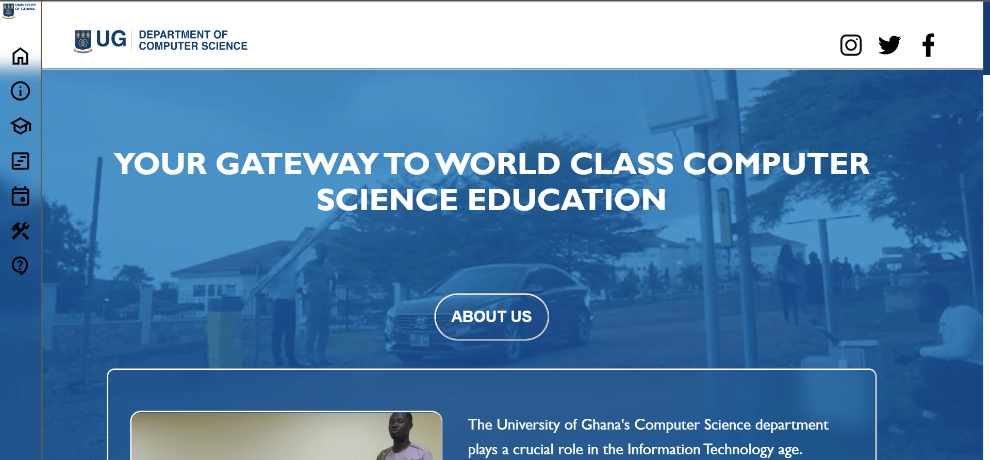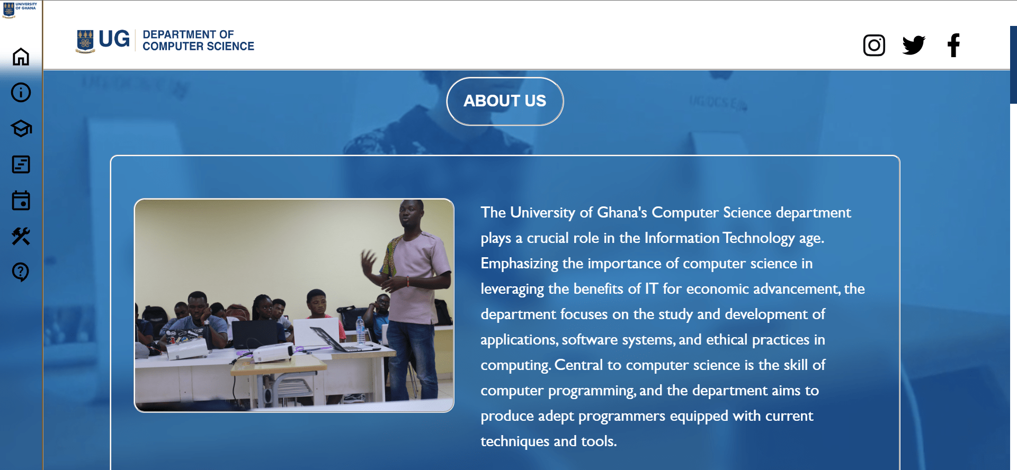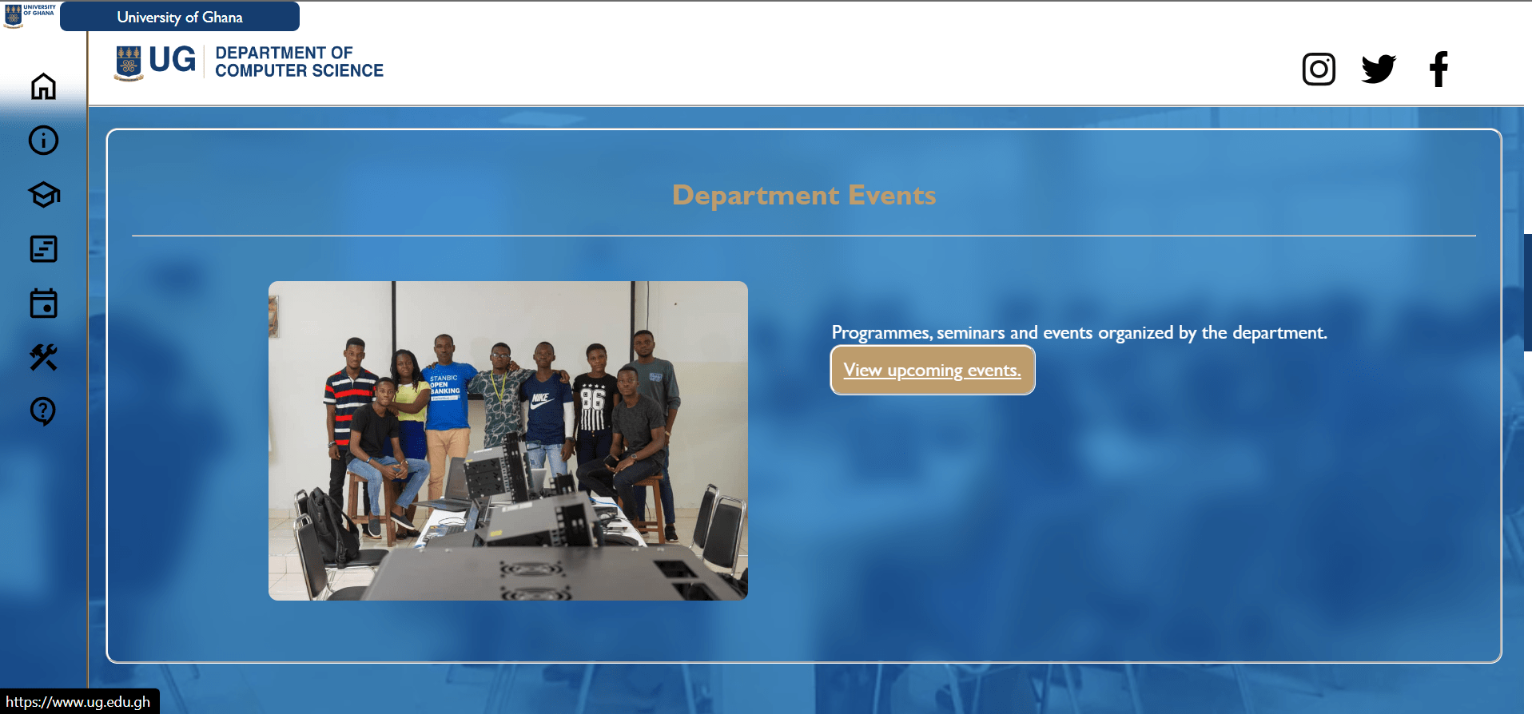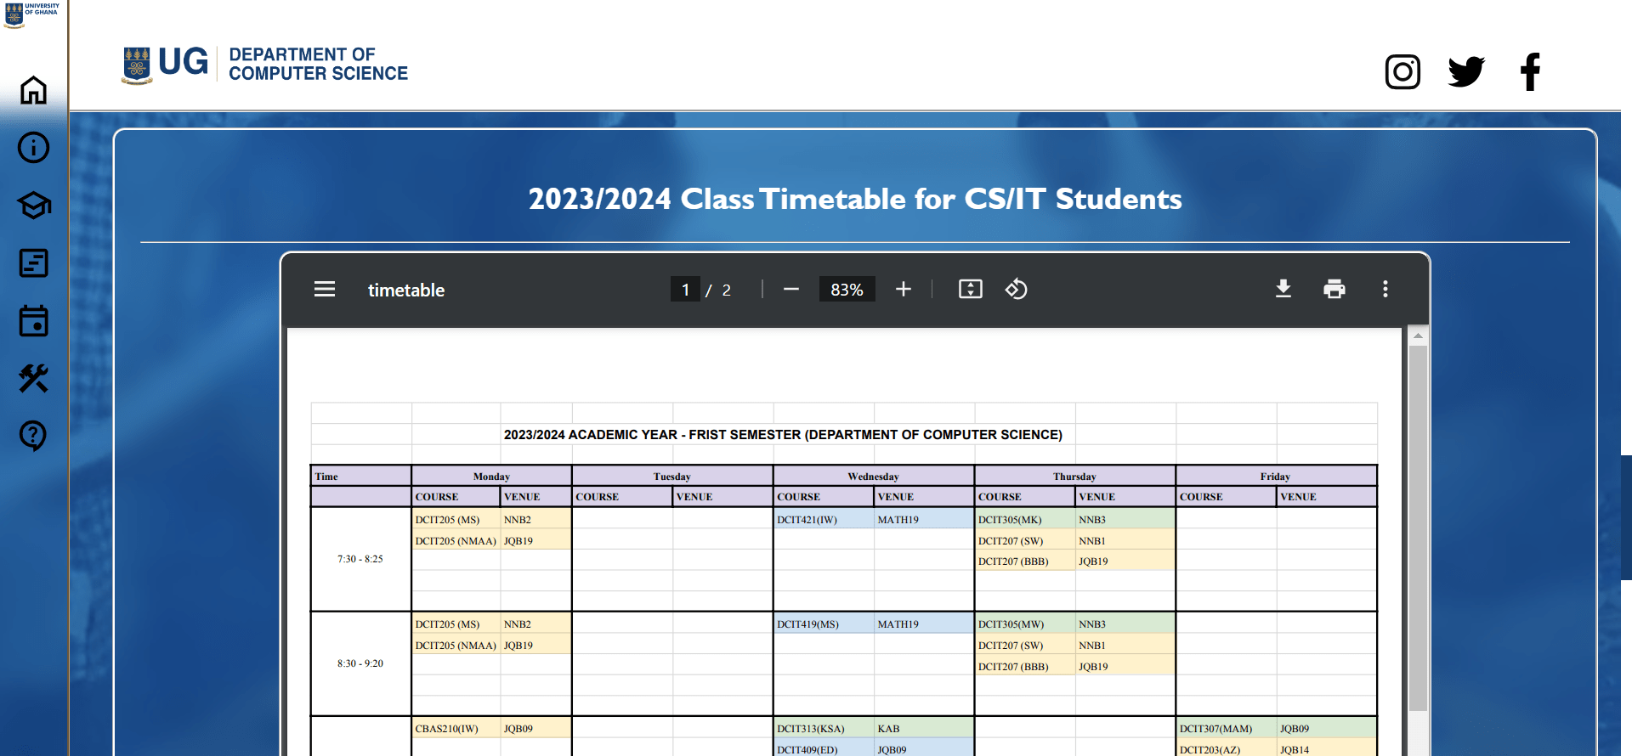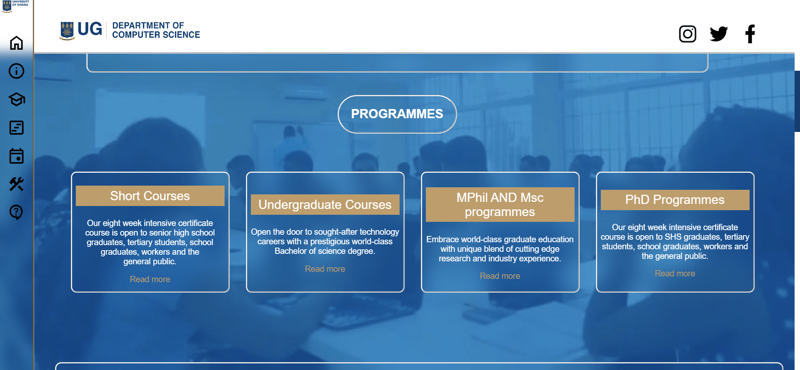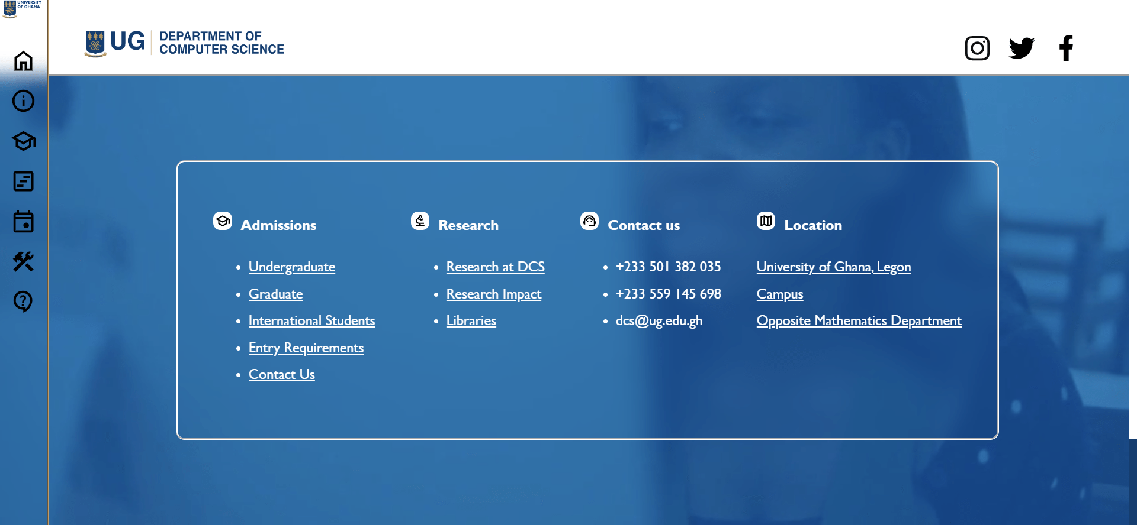

1. About Page

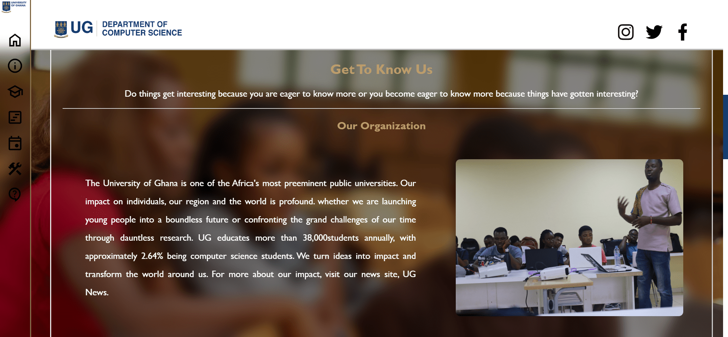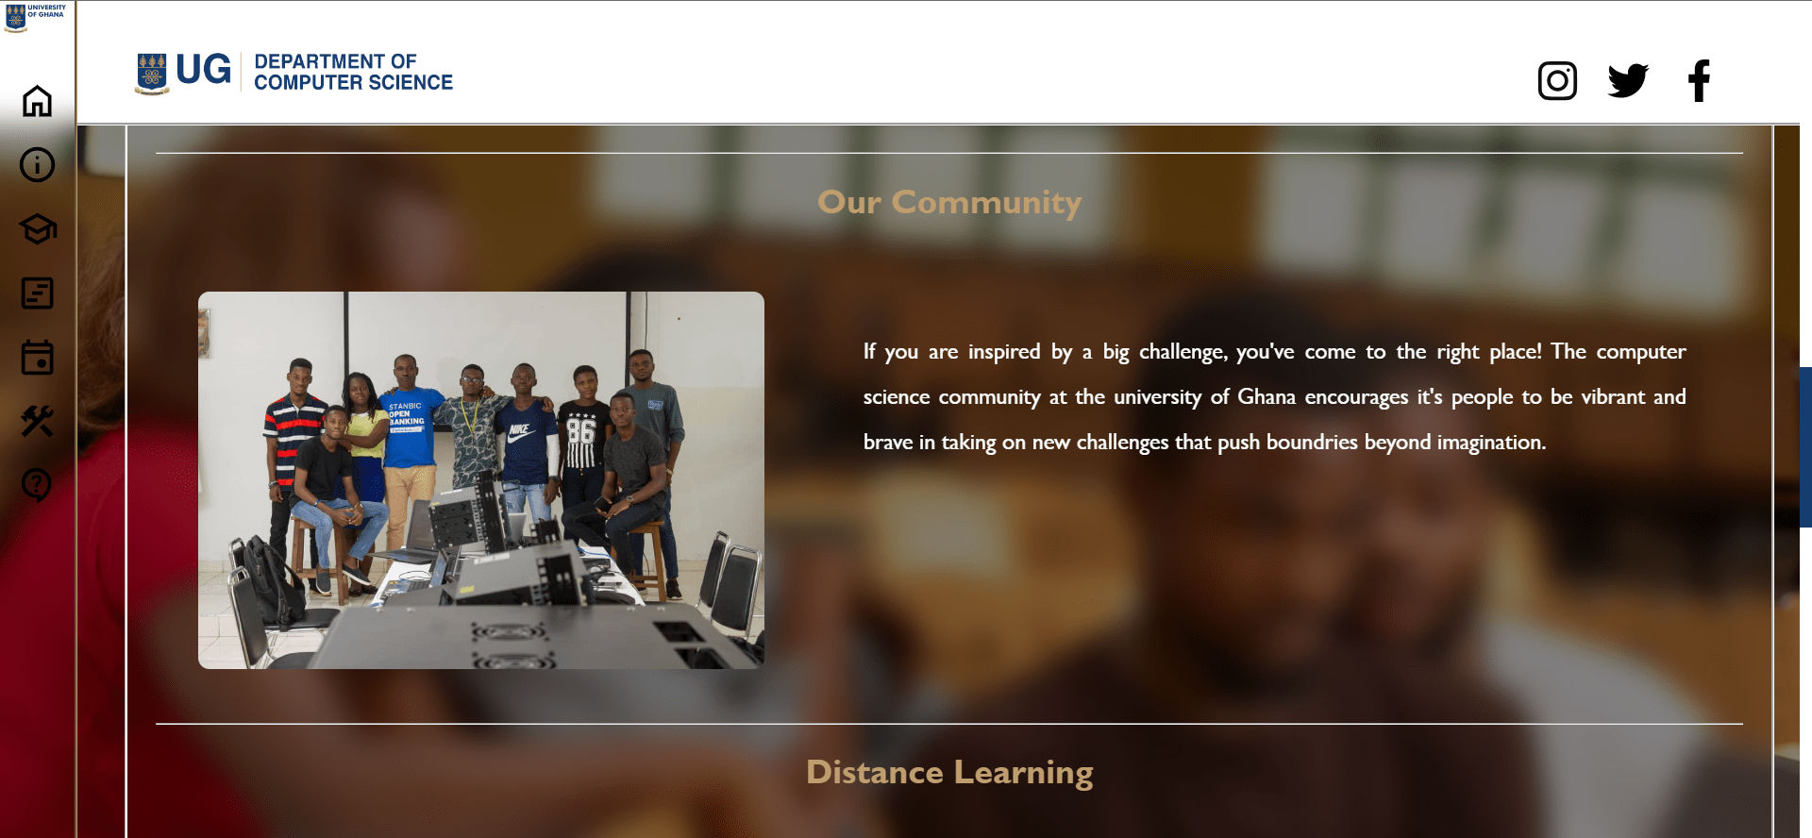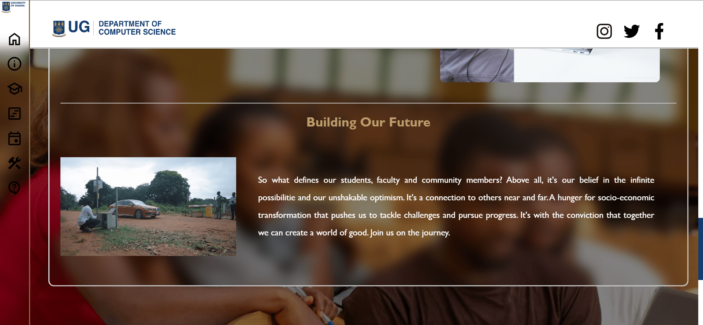

3. Programmes Offered



4. Short Courses page



1. Undergraduate courses page

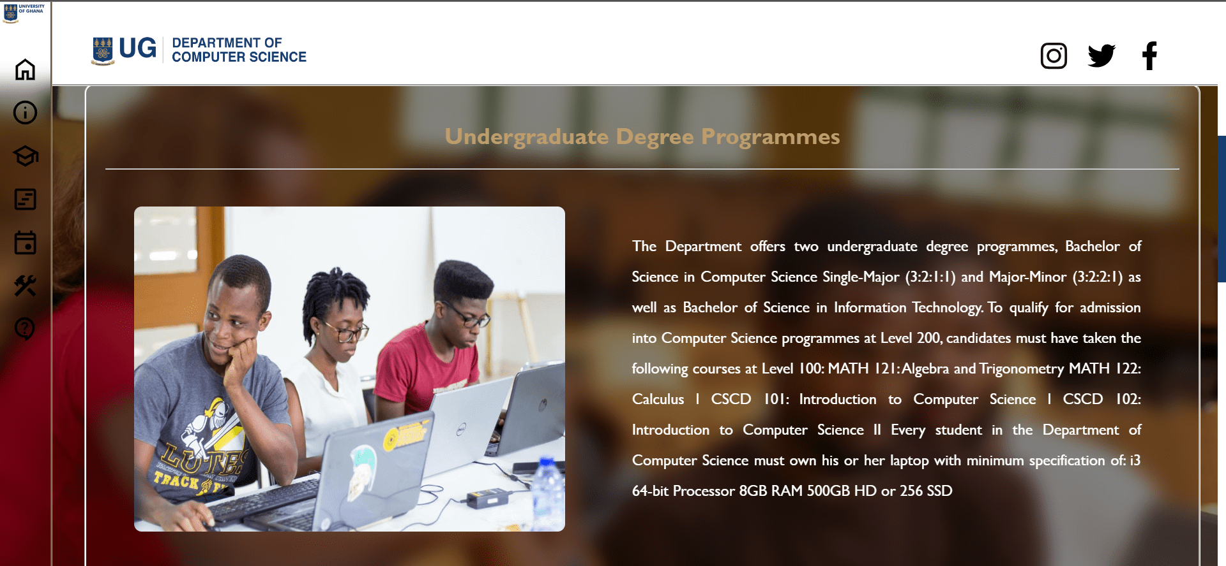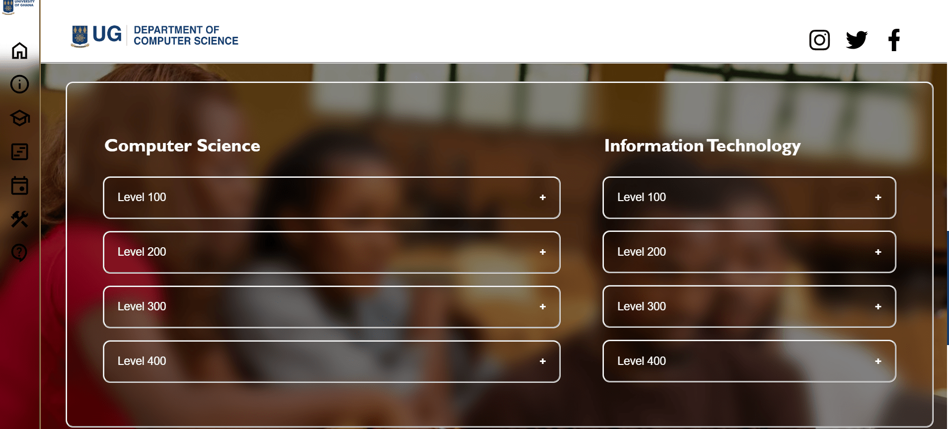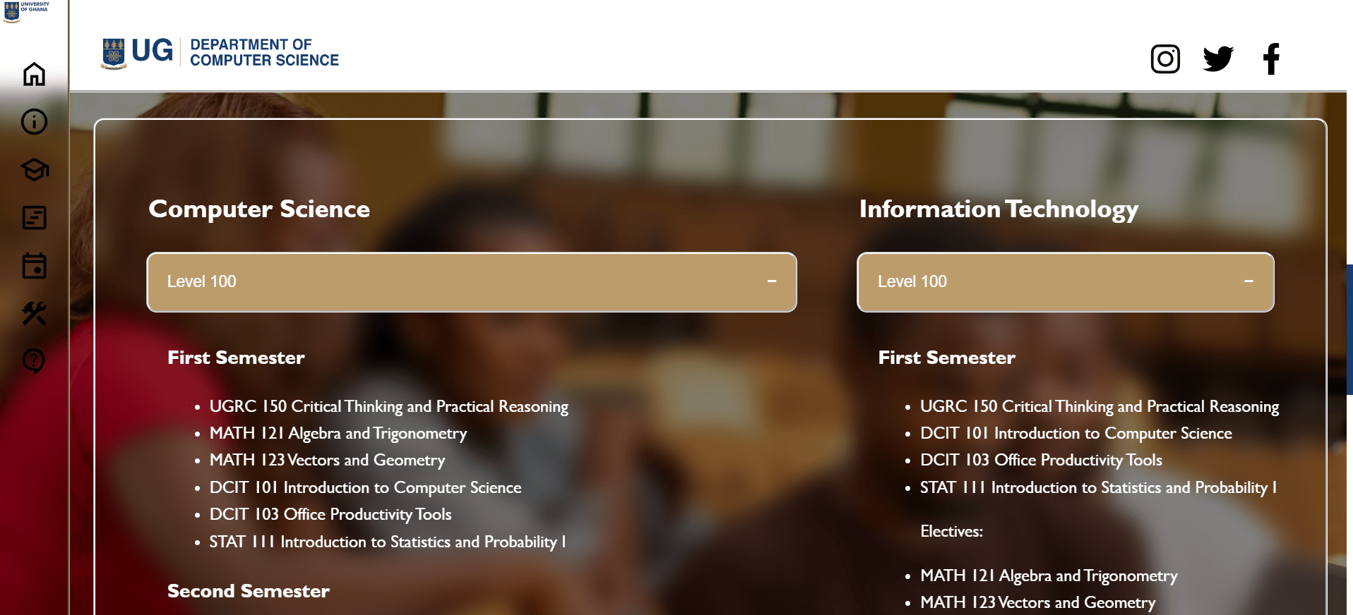

1. MPhil/MSc courses page

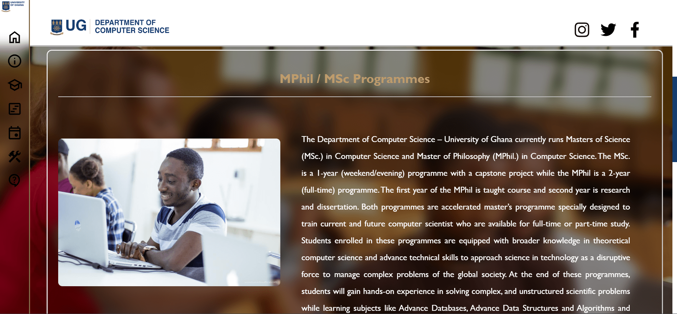

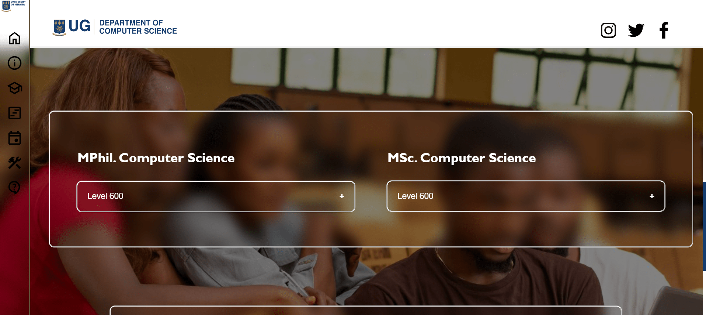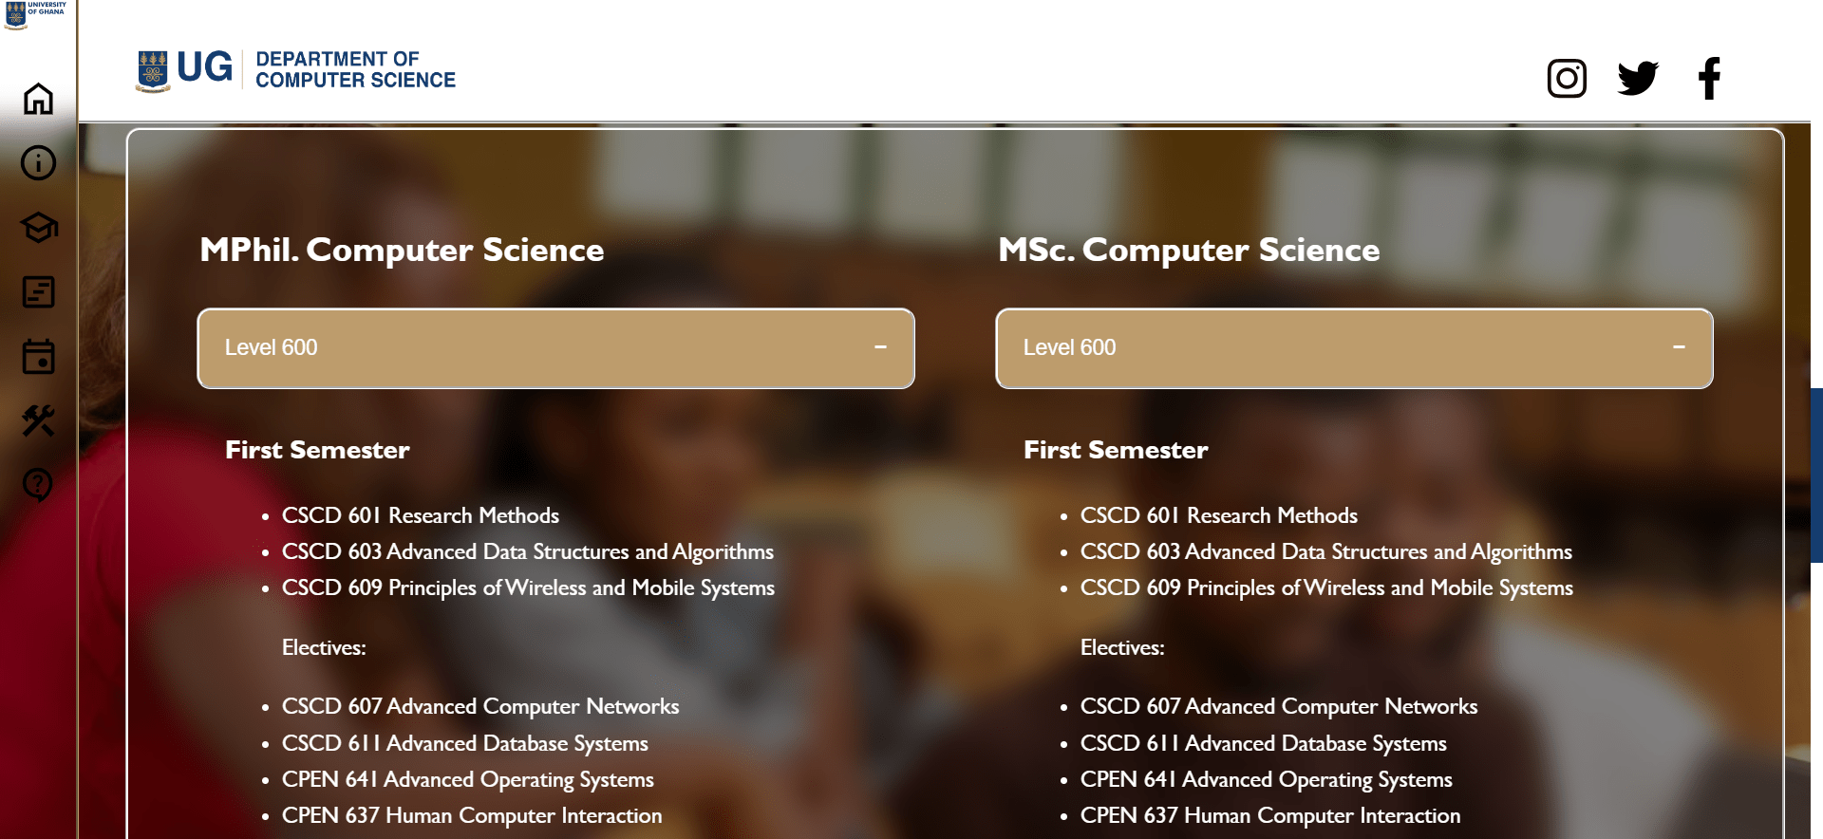

1. PhD programmes page

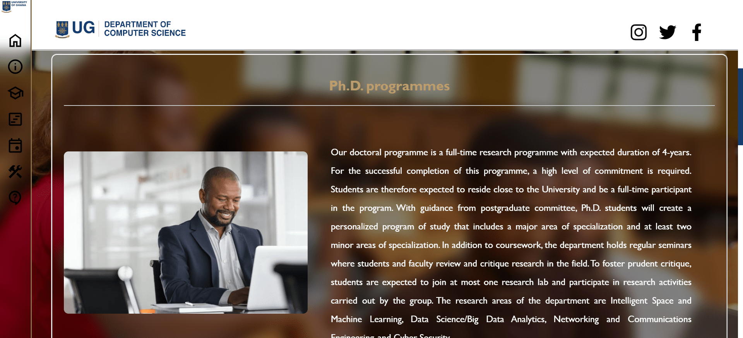

1. School and Class timetables Page

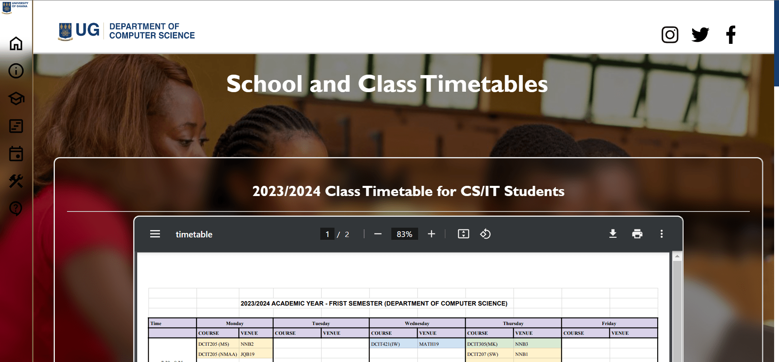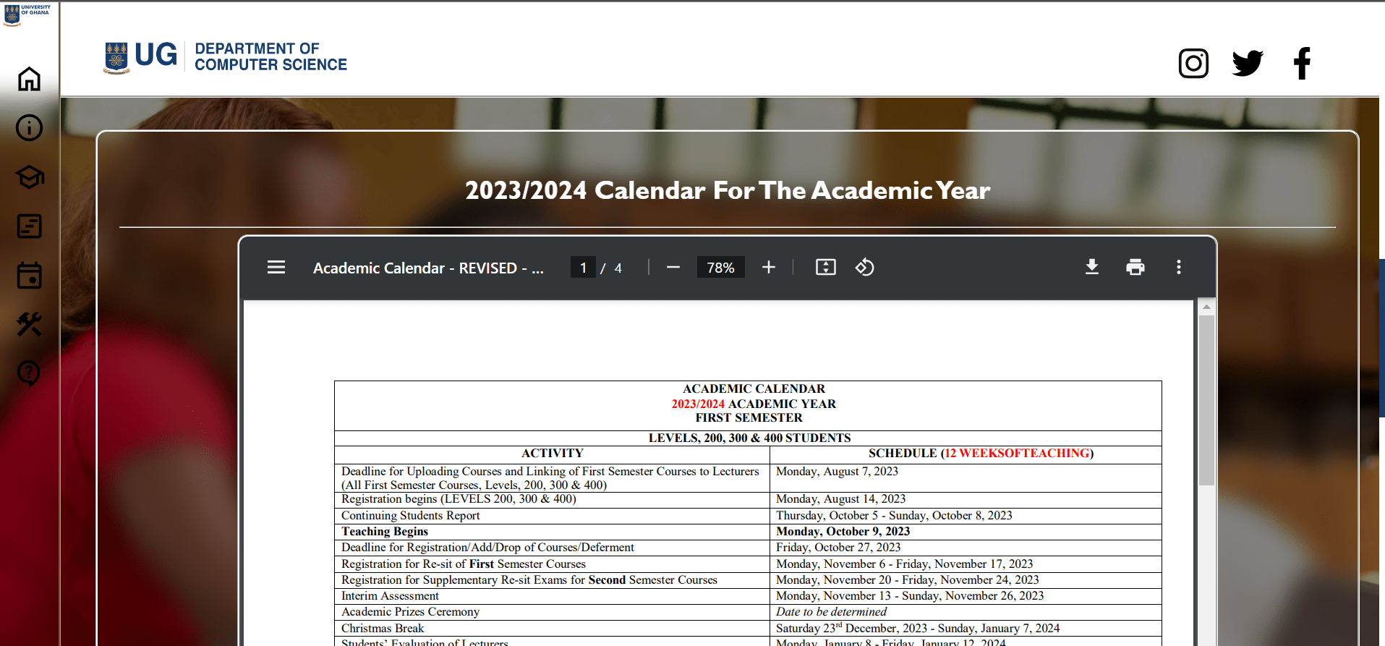

1. Department events page

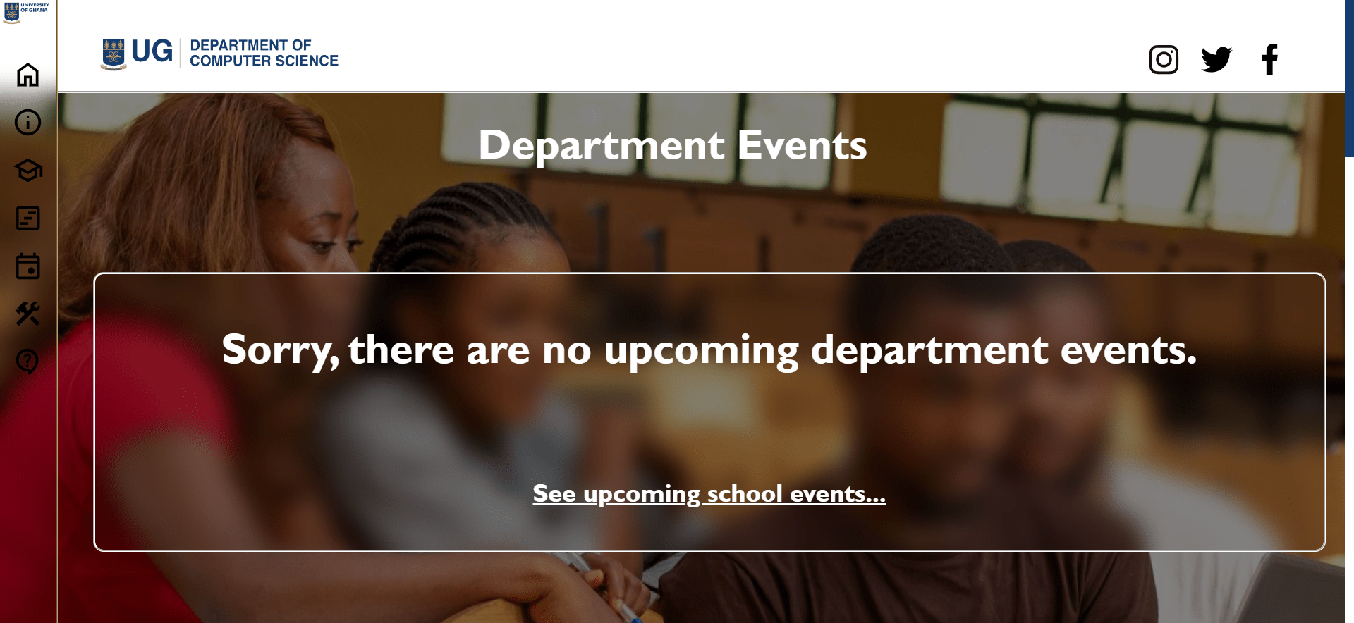

1. Resources page

